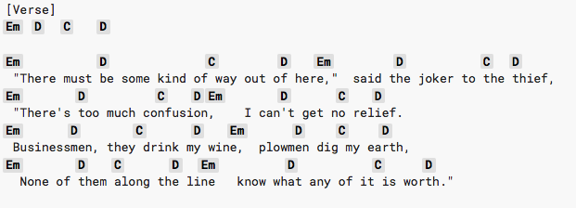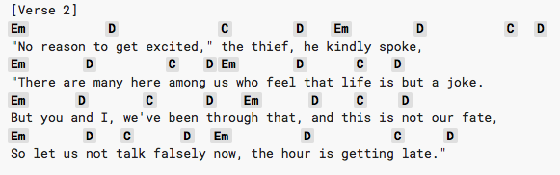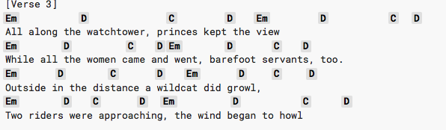

**All Along The Watch Tower Capo 5**